

**UNIVERSITI MALAYSIA TERENGGANU**

**CSM 3103 PROGRAMMING FRONT-END**

**BACHELOR OF COMPUTER SCIENCE (MOBILE COMPUTING)**

**LAB 3**

**SEMESTER II 2023/2024**

**PREPARED FOR:**

**DR. RABIEL BIN MAMAT**

**PREPARED BY:**

**NUR IZZATI NAJWA BINTI MOHD BAKHRI (S65417)**

- Create emulator

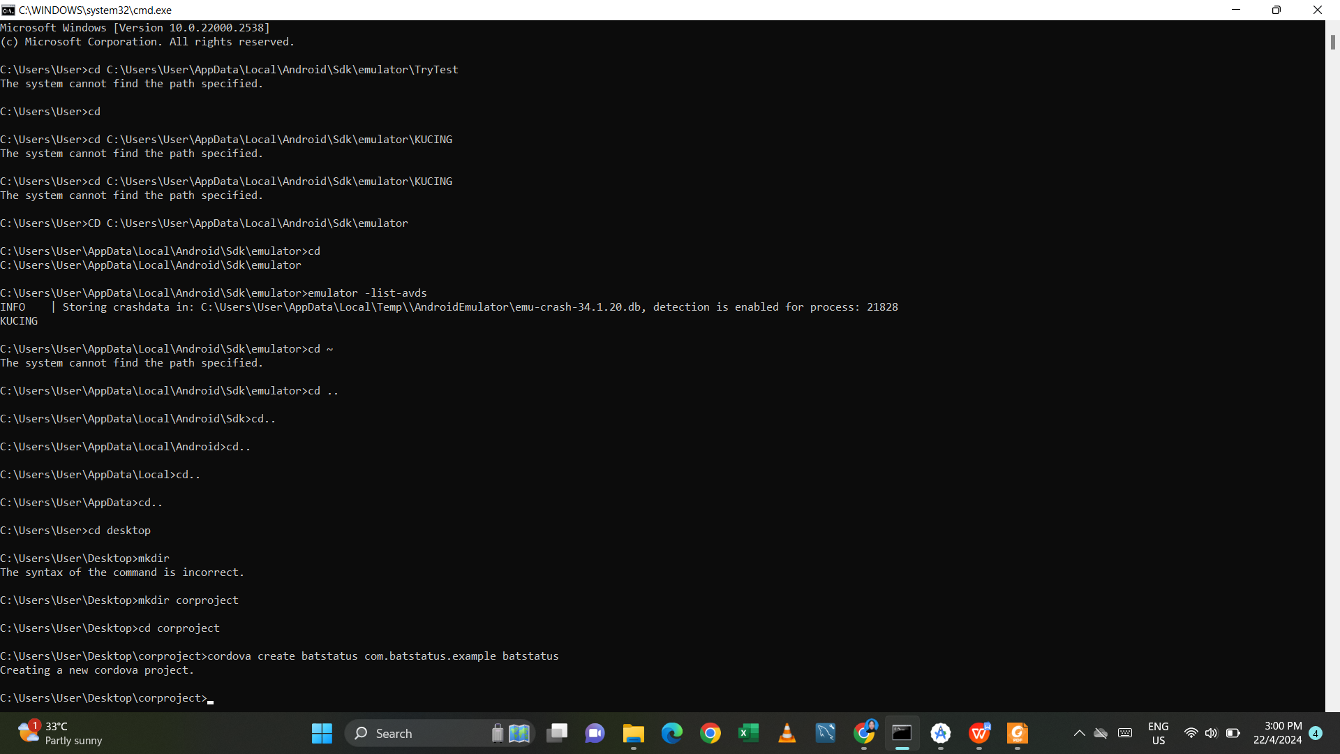

**Task 1 – Battery Plugin**

1. Create new cordova project – batstatus
2. Add android platform
3. Add battery plugin – cordova plugin add cordova-plugin-battery-status

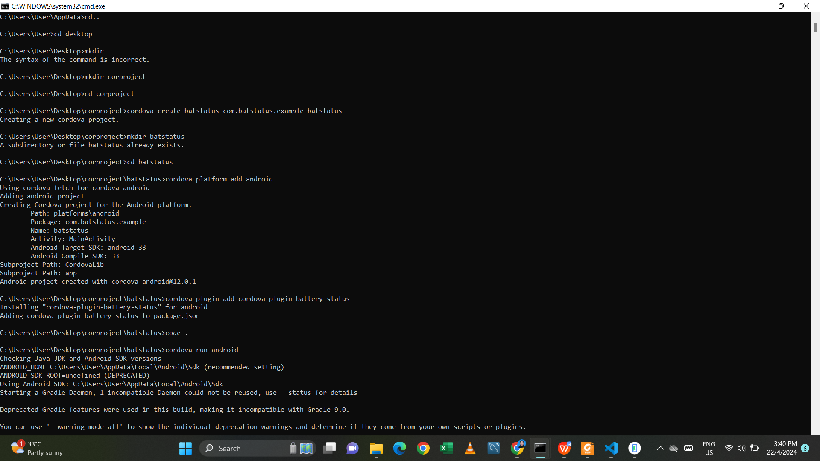

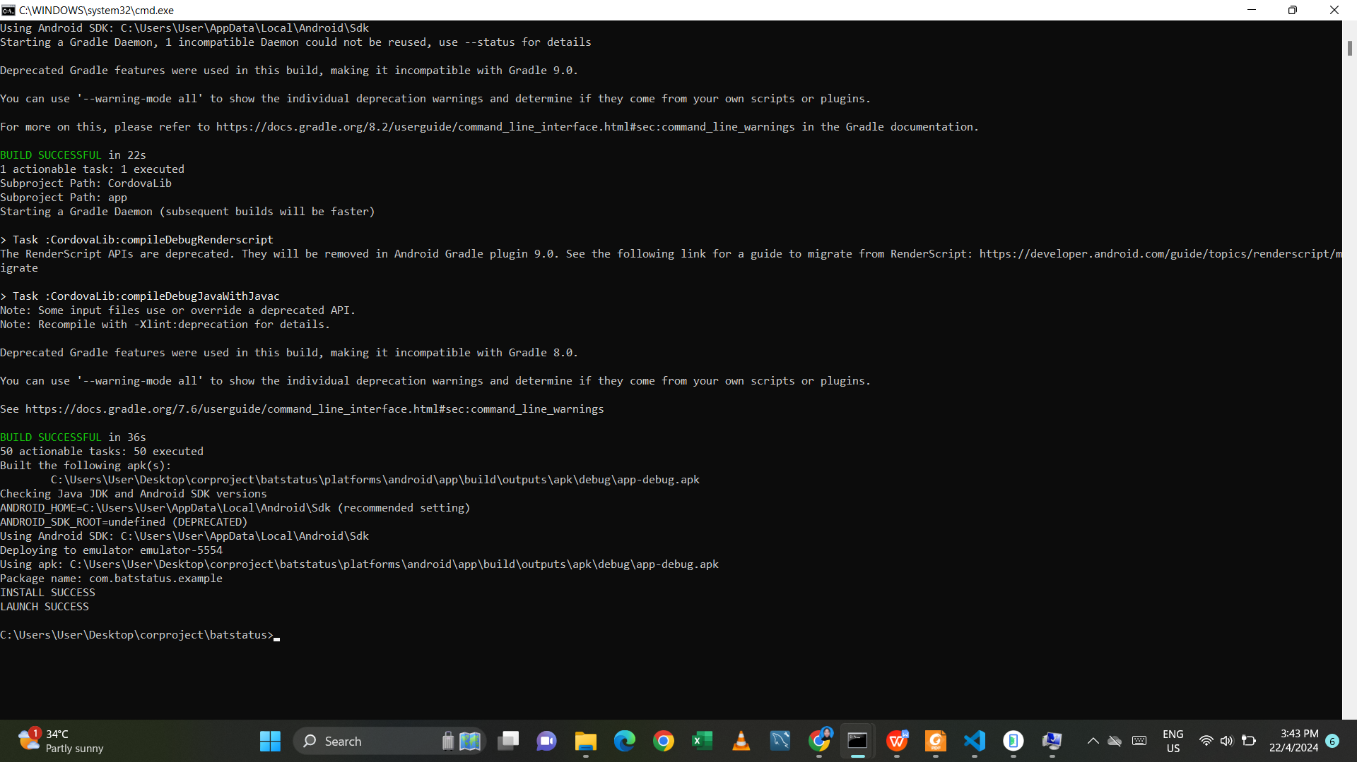

1. Open index.js and put the following code inside onDeviceReady function

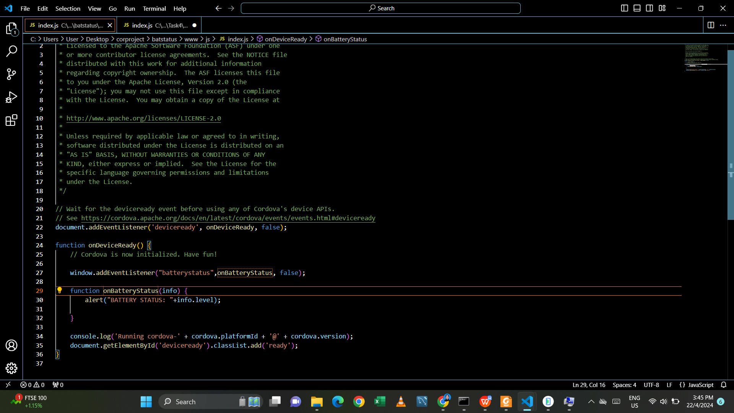

1. Test your code using emulator

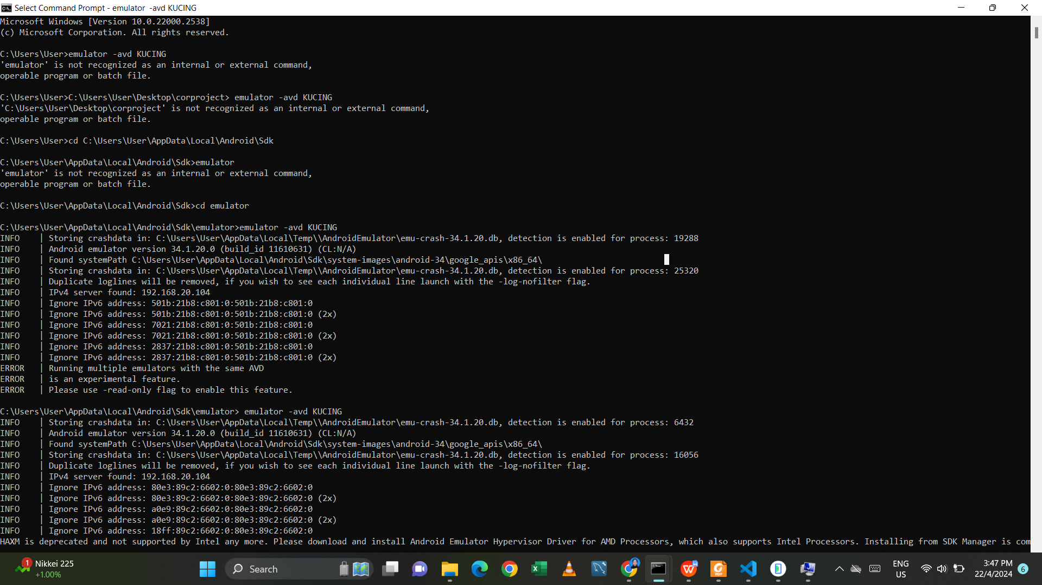

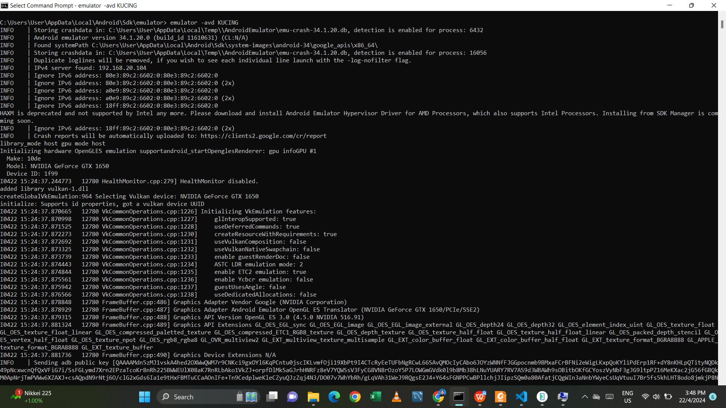

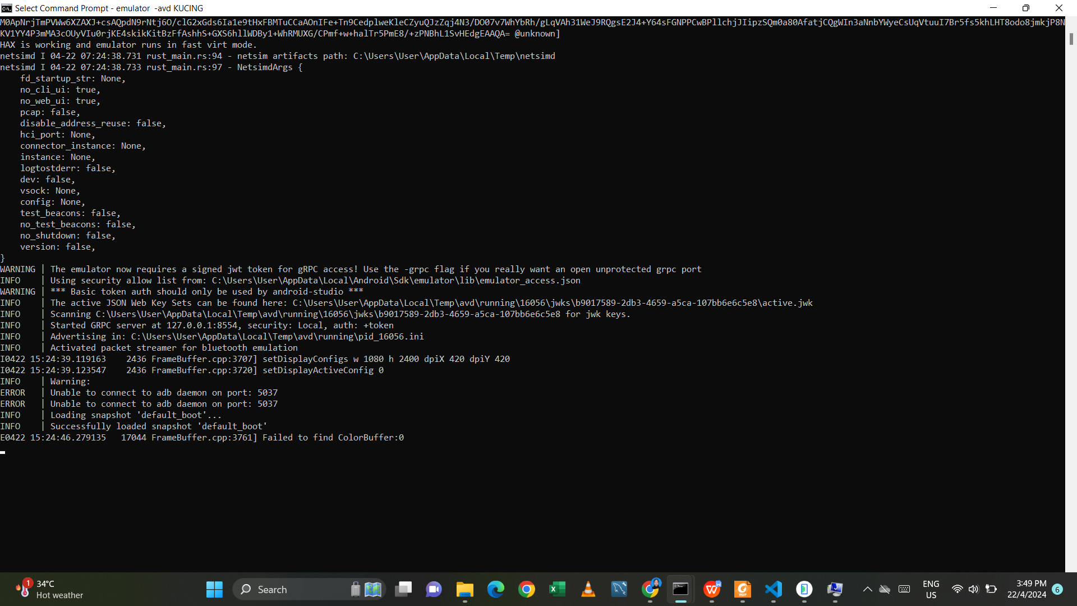

1. Output on android

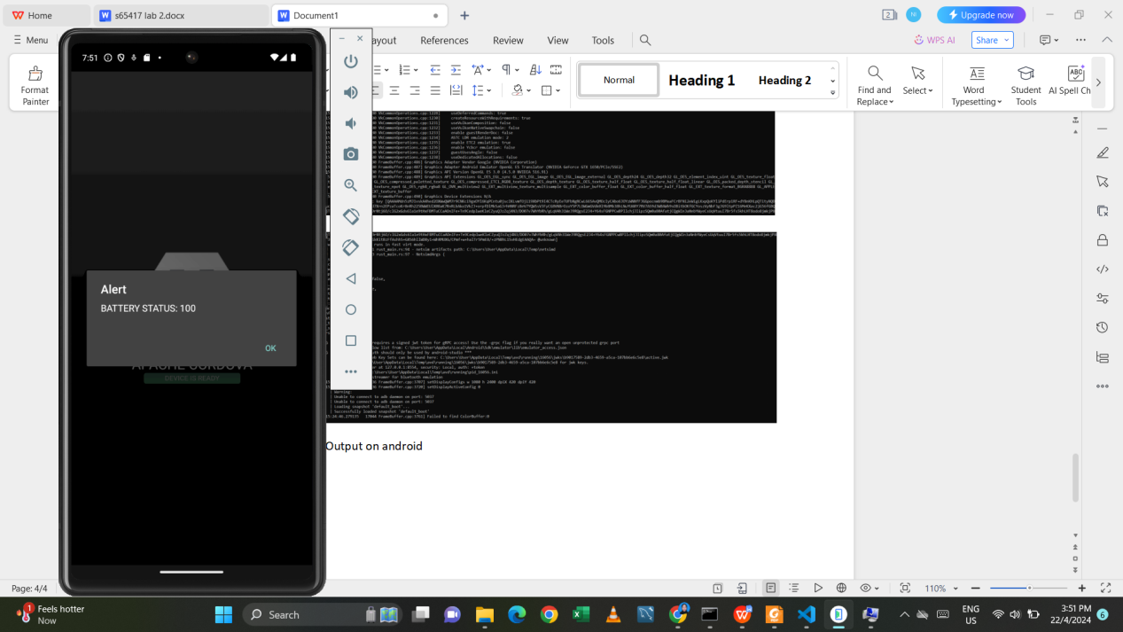

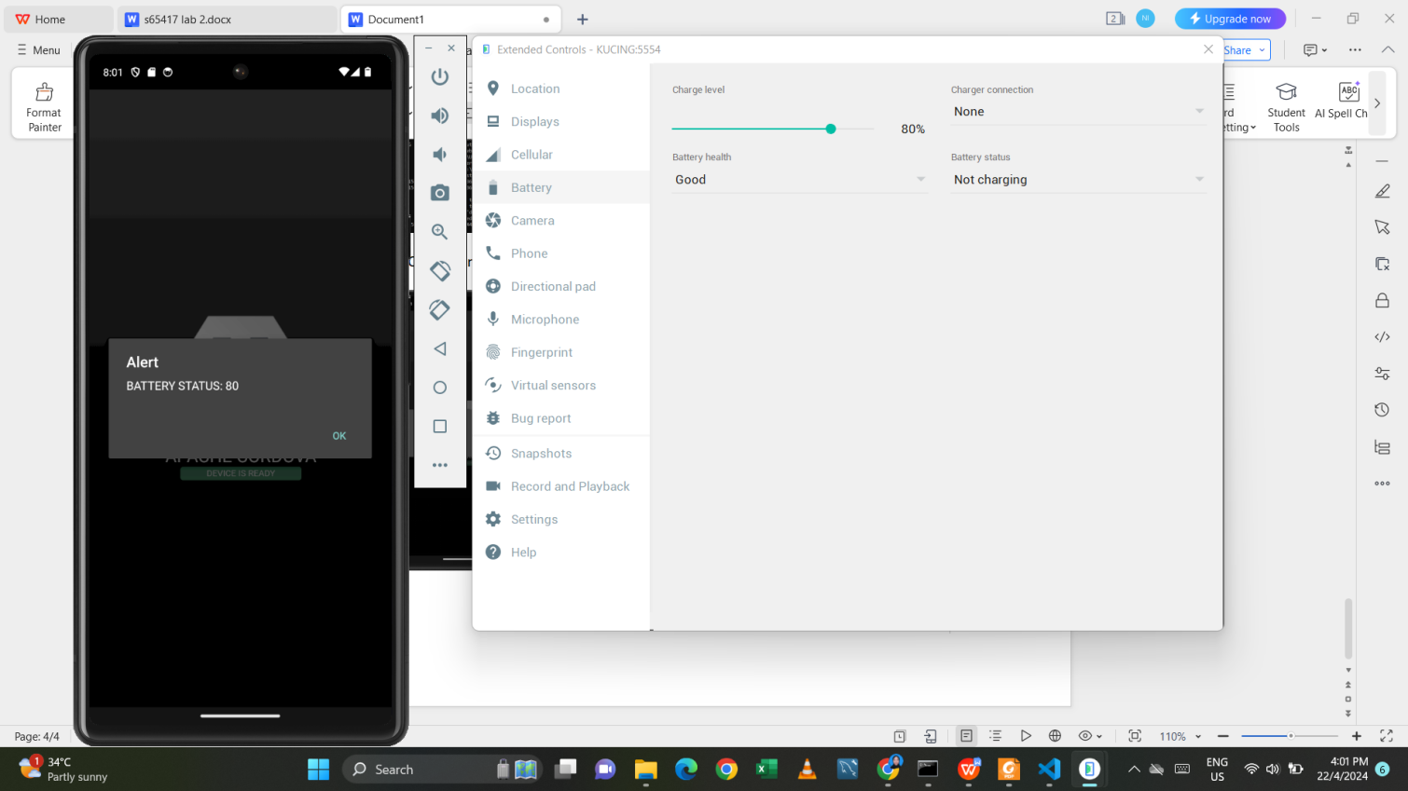

1. Add to your index.js, a code to determine either the phone is on charging or not.

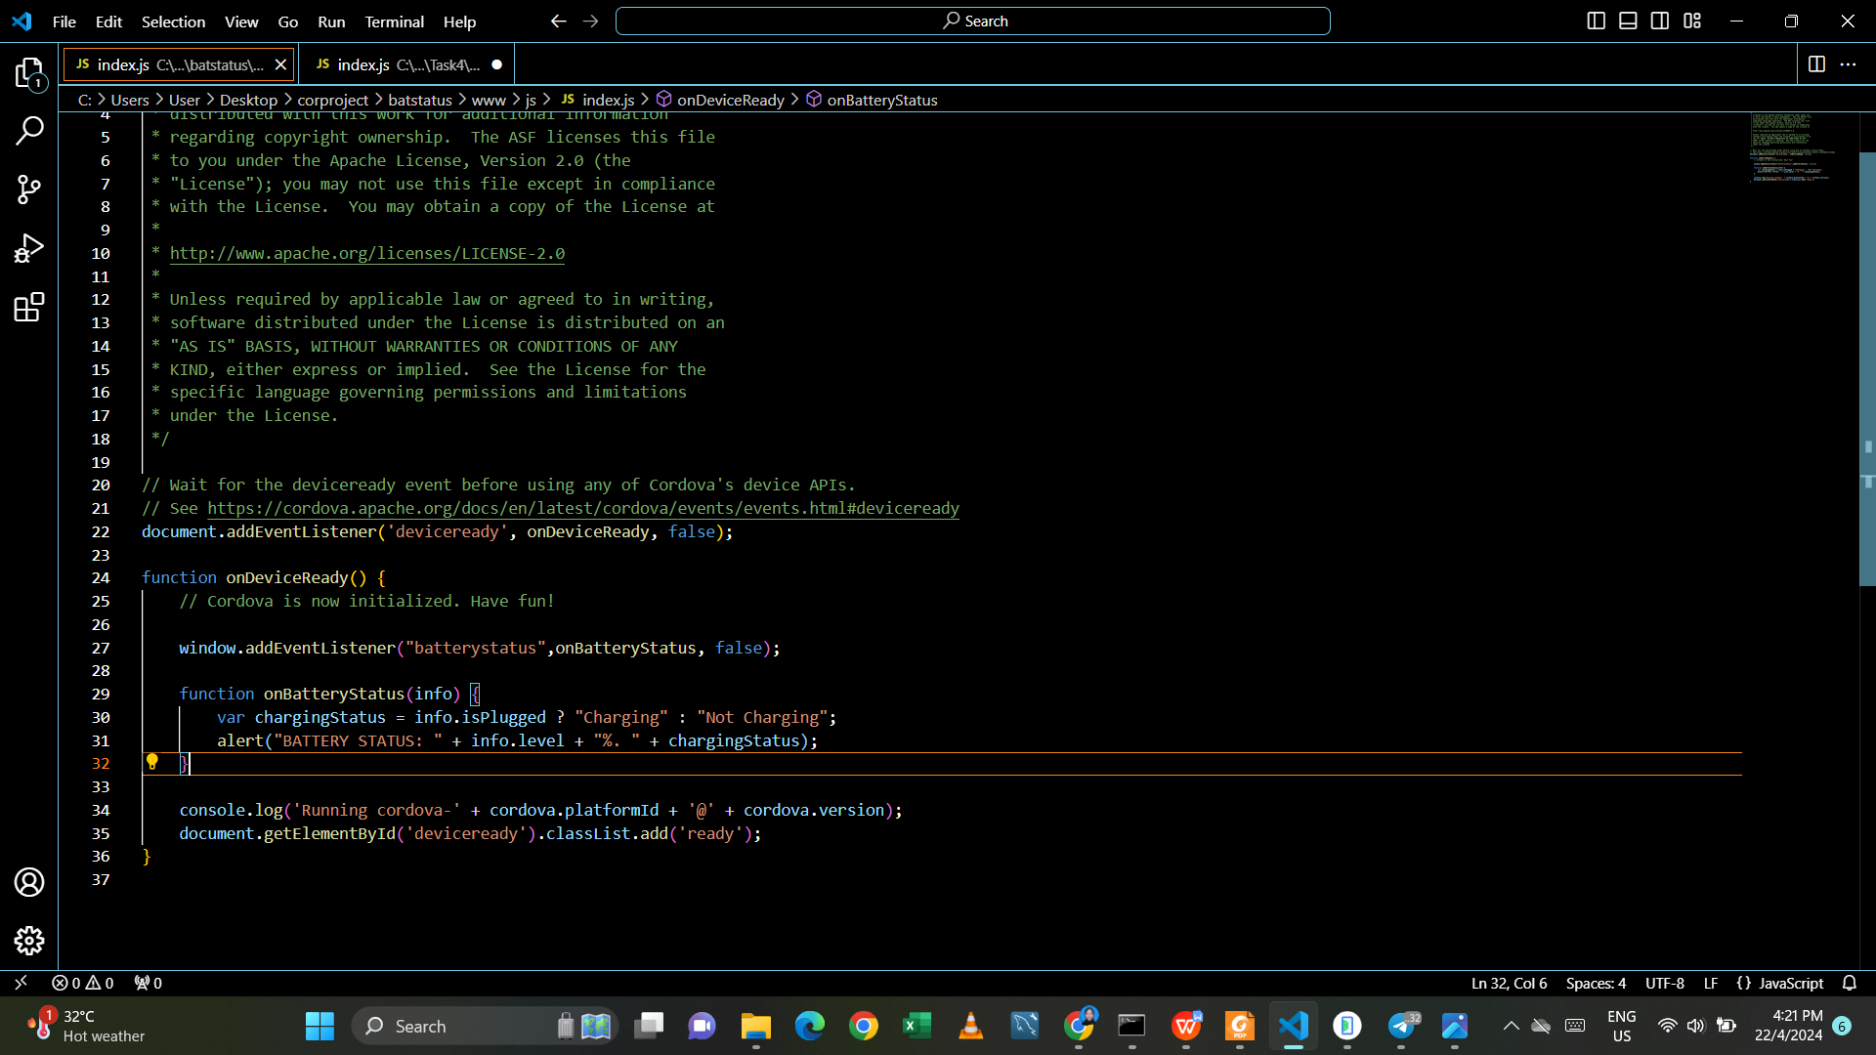

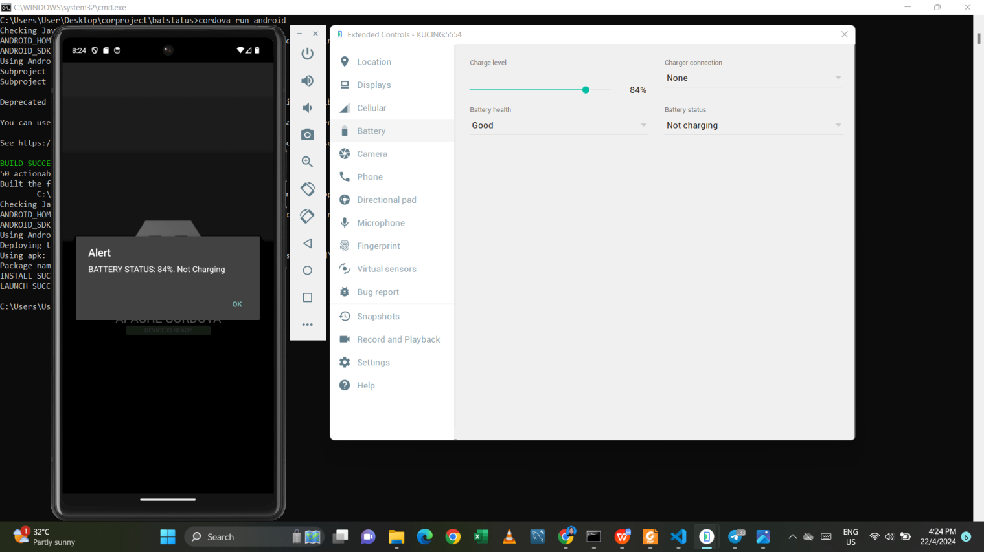

**Task 2 - Camera Plugin**

1. Create new cordova project – camfunctiom
2. Add android platform
3. Add camera plugin : cordova-plugin-camera

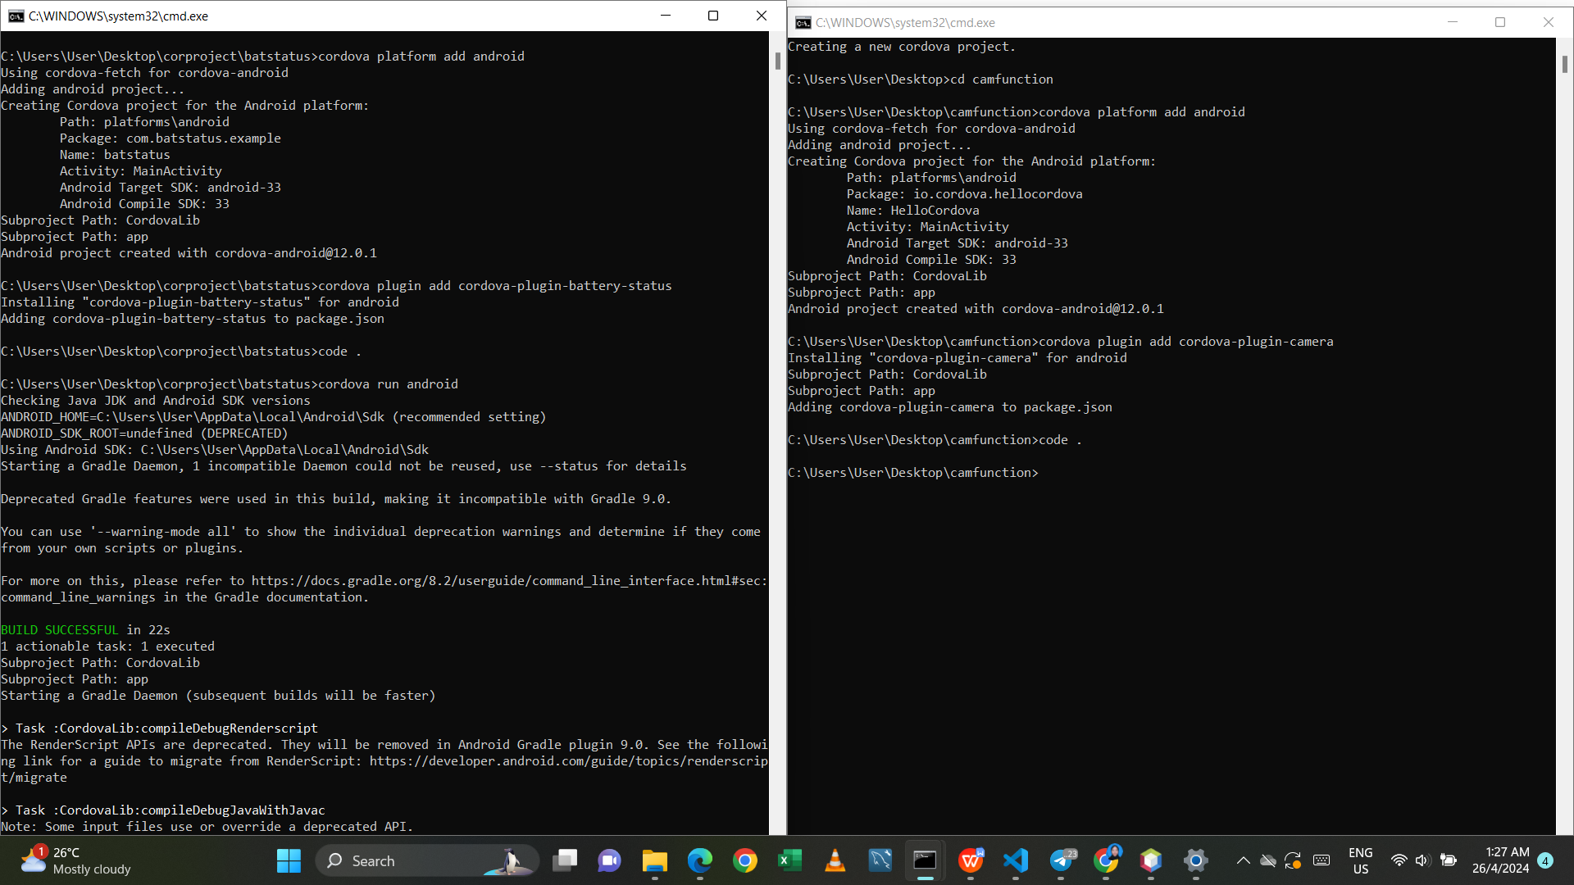

1. Open index.html

a. Remove everything inside <div class=”app”>

b. Add the following

1. <h1>Camera Function</h1>
2. <button id=”takePic”>Take Picture</button>
3. <img id=”myimage”></img>

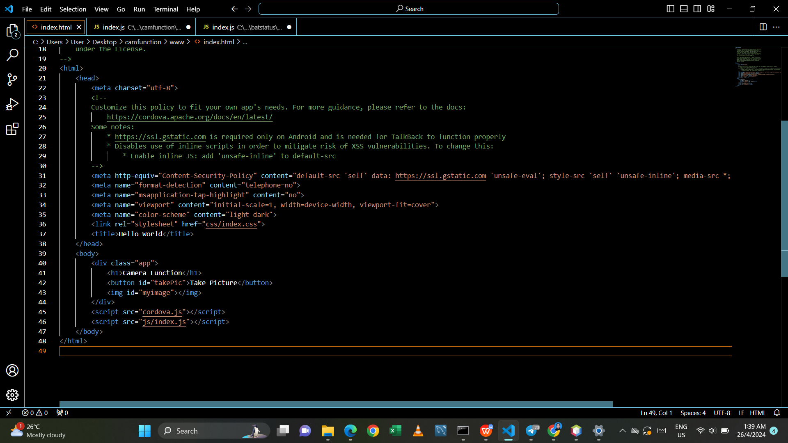

1. Open index.js
2. Remove everything inside onDeviceReady Function
3. Add the following code

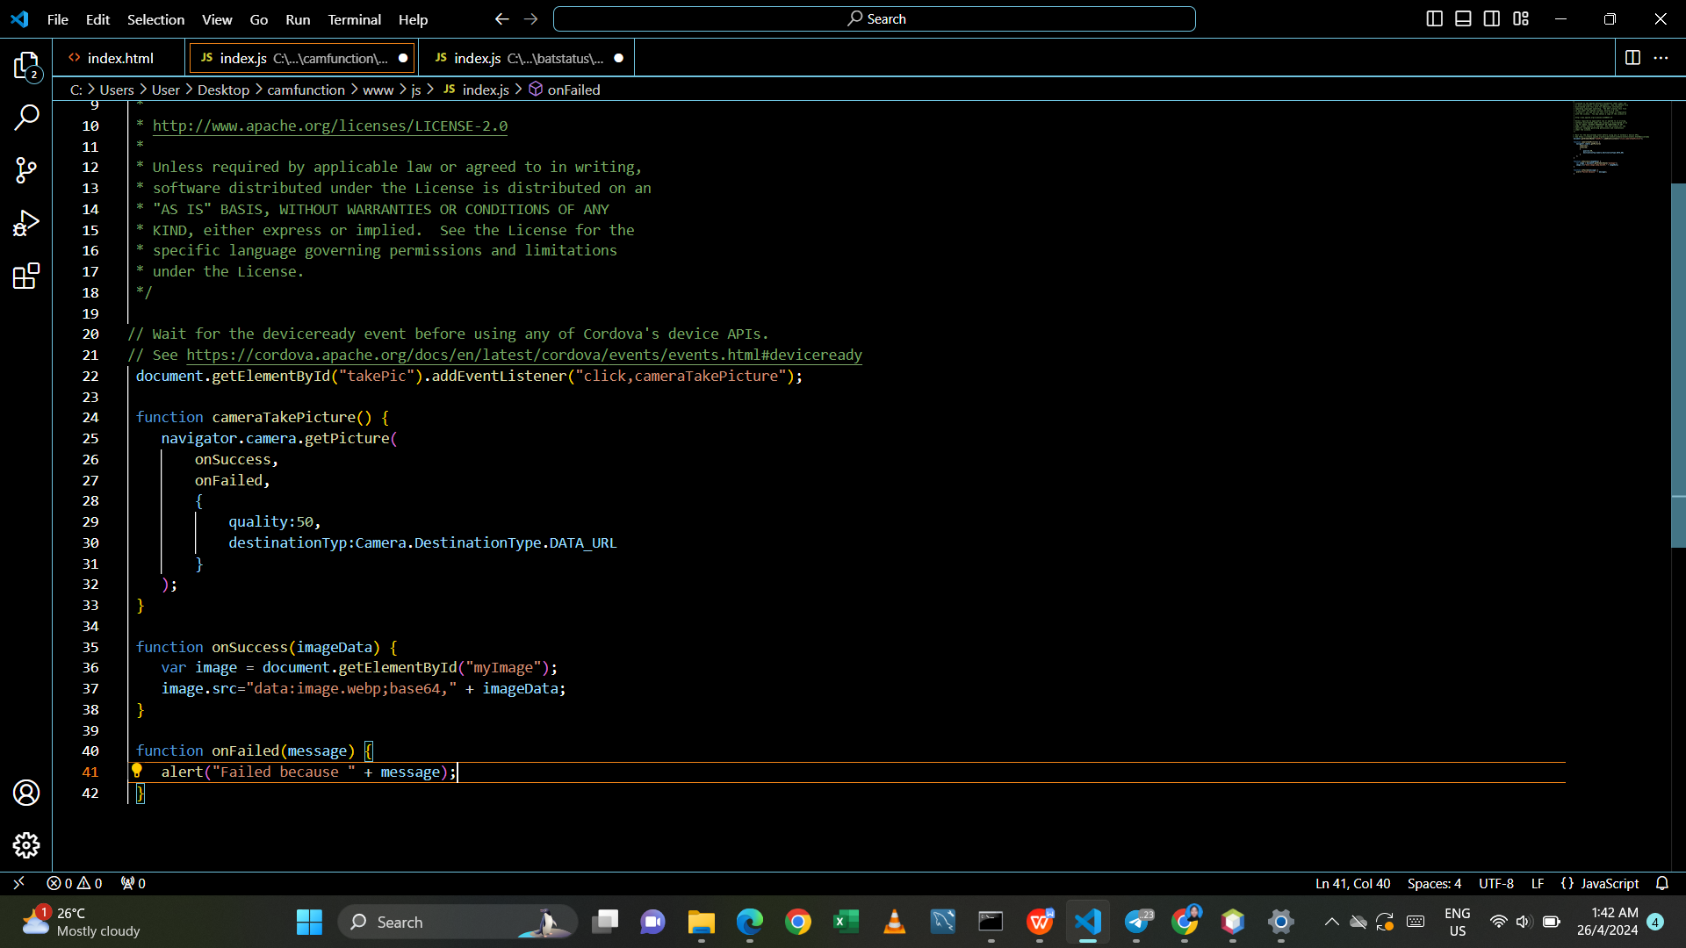

1. Cordova run android

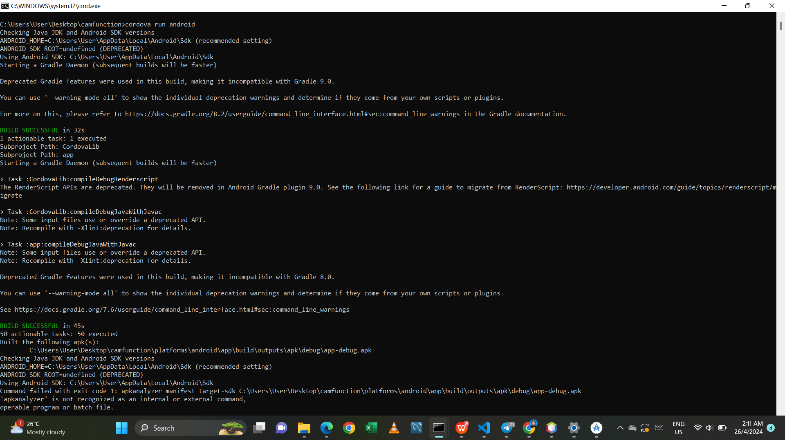

1. Output on android

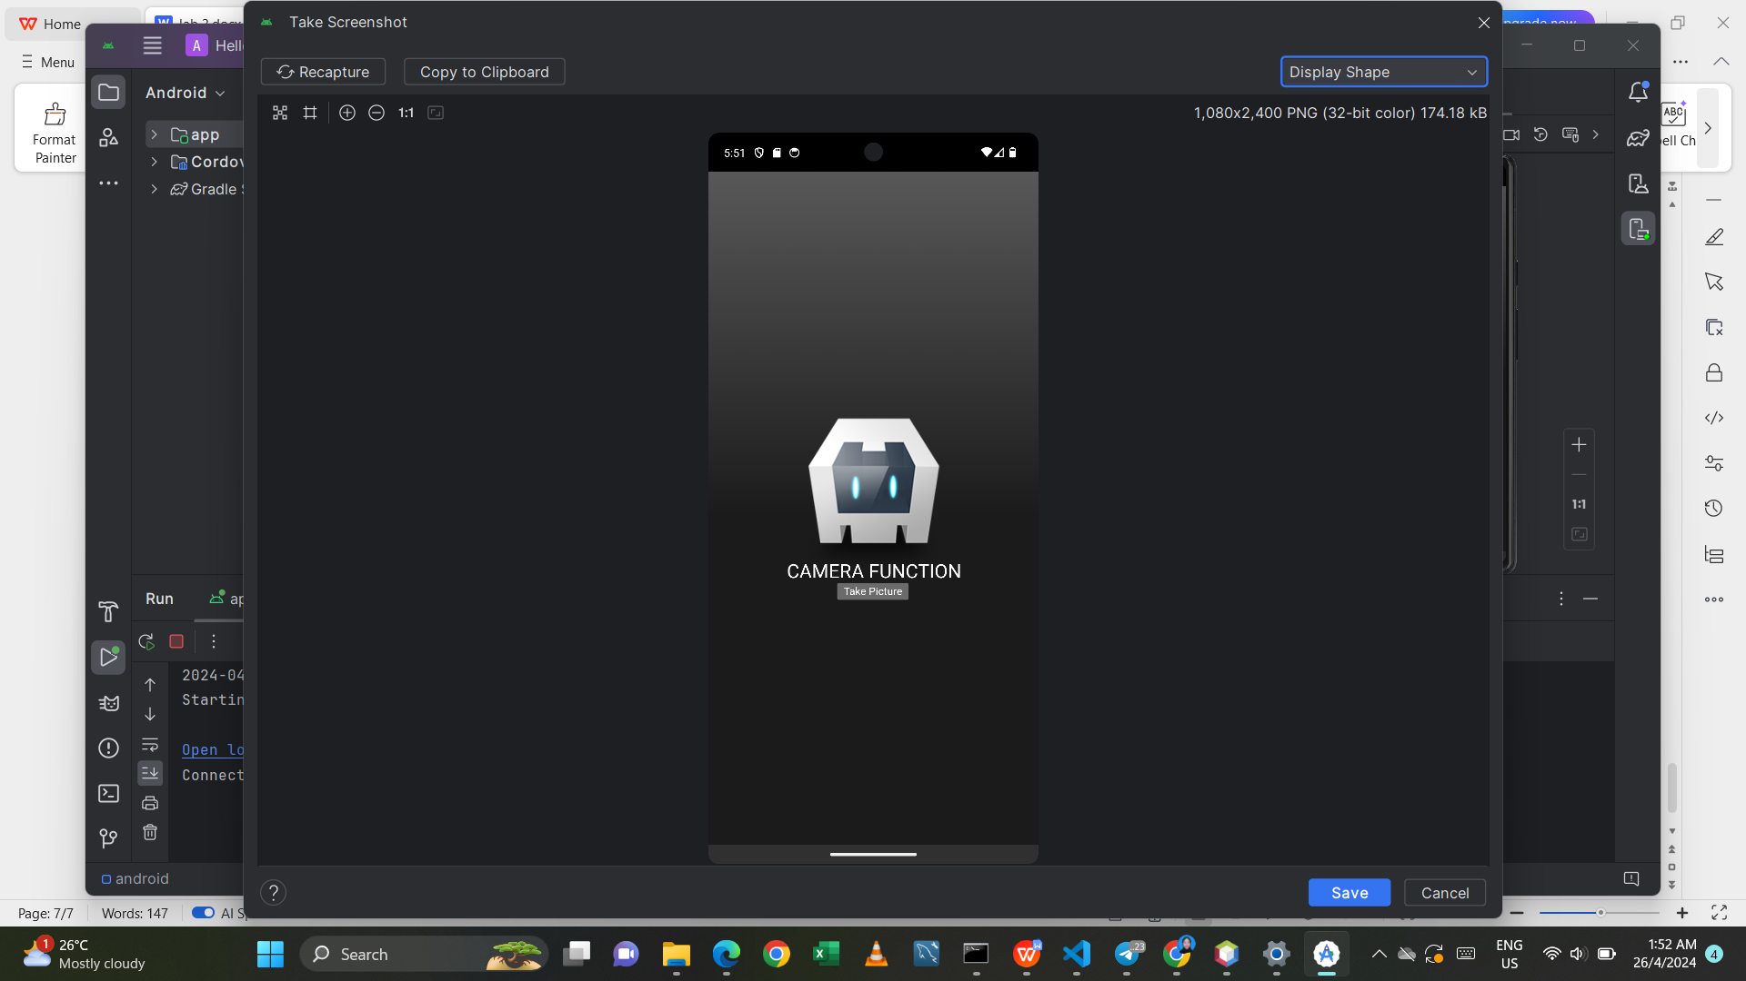

1. Screenshot on desktop

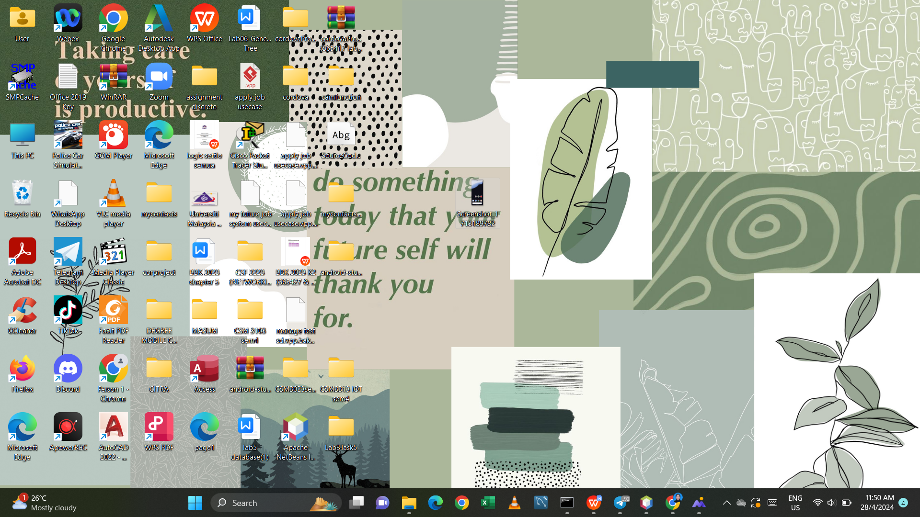

**Task 3 – Contacts**

1. Create a new cordova project – mycontacts

2. Add android platform

3. Add contact plugin – cordova-plugin-contacts

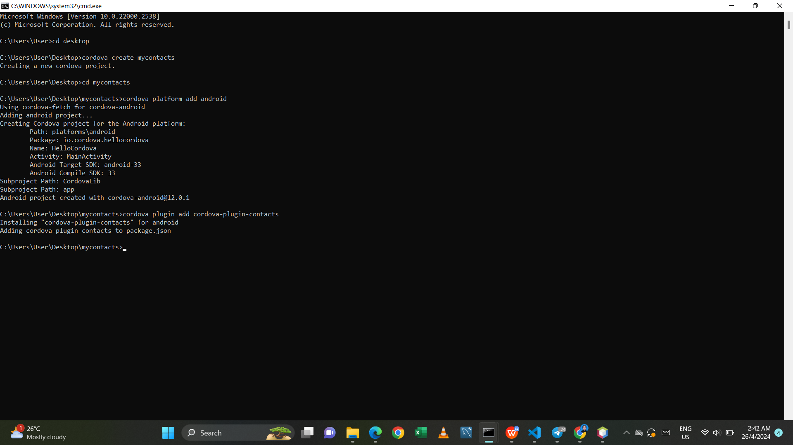

1. Open index.html and remove all inside <div class=”app”> and put the following code.

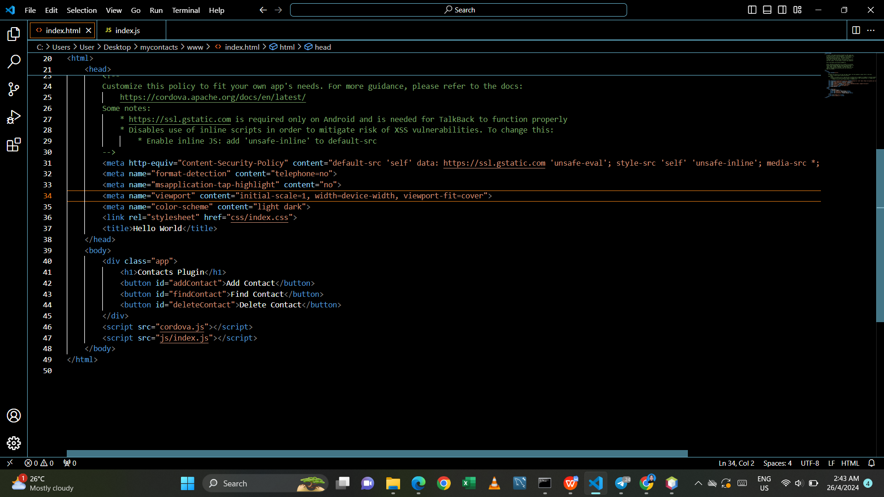

1. Open index.js and remove all codes inside onDeviceReady function and add the following code.

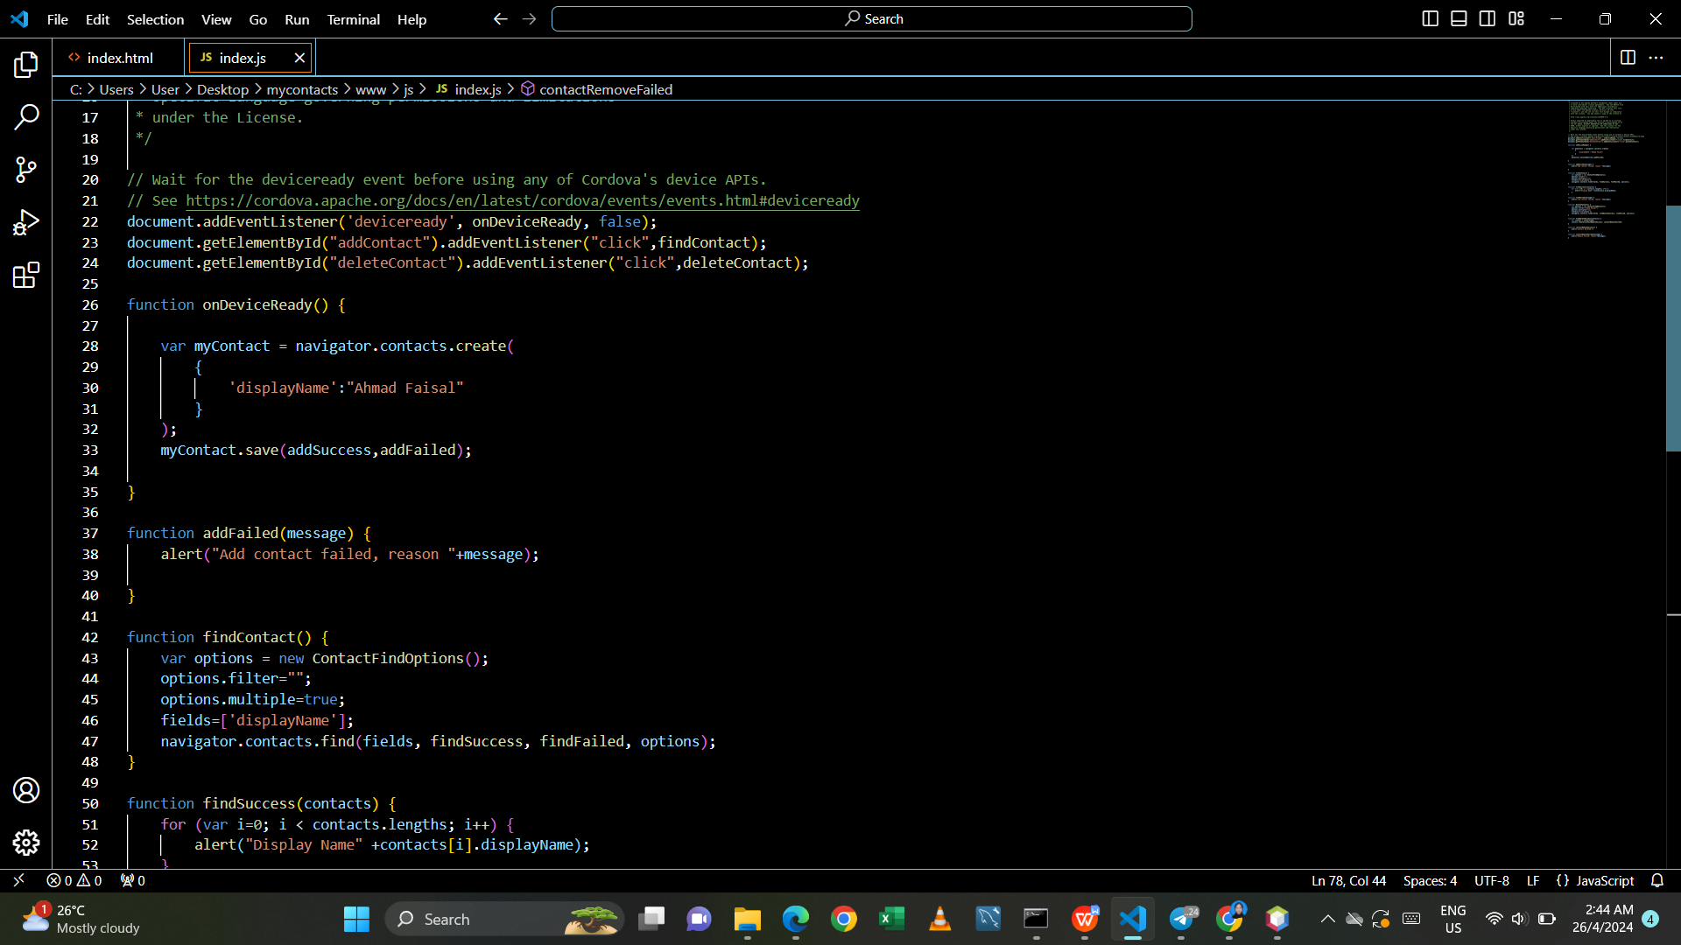

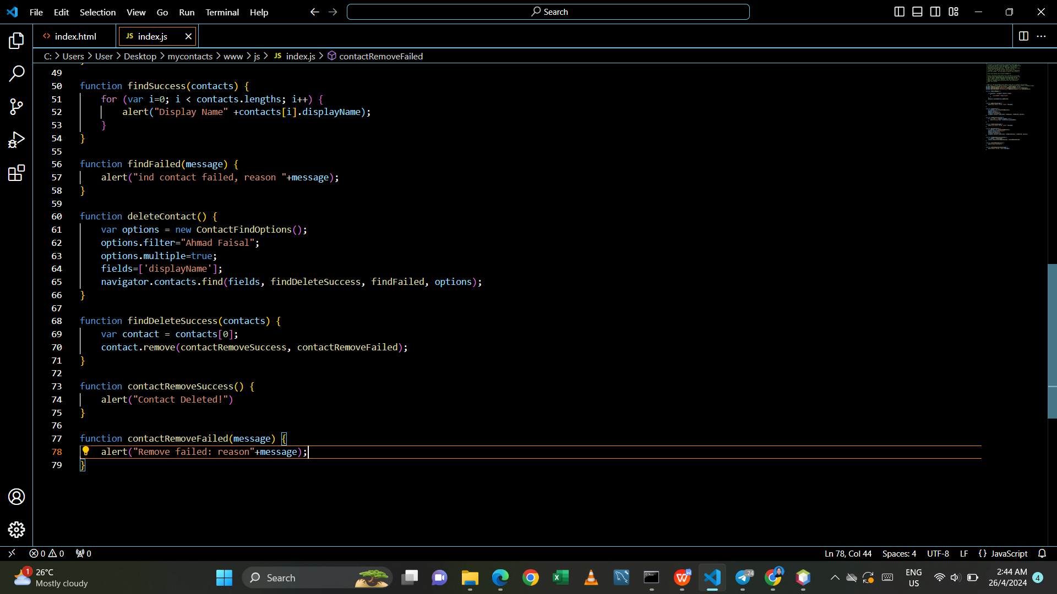

1. Test your code.

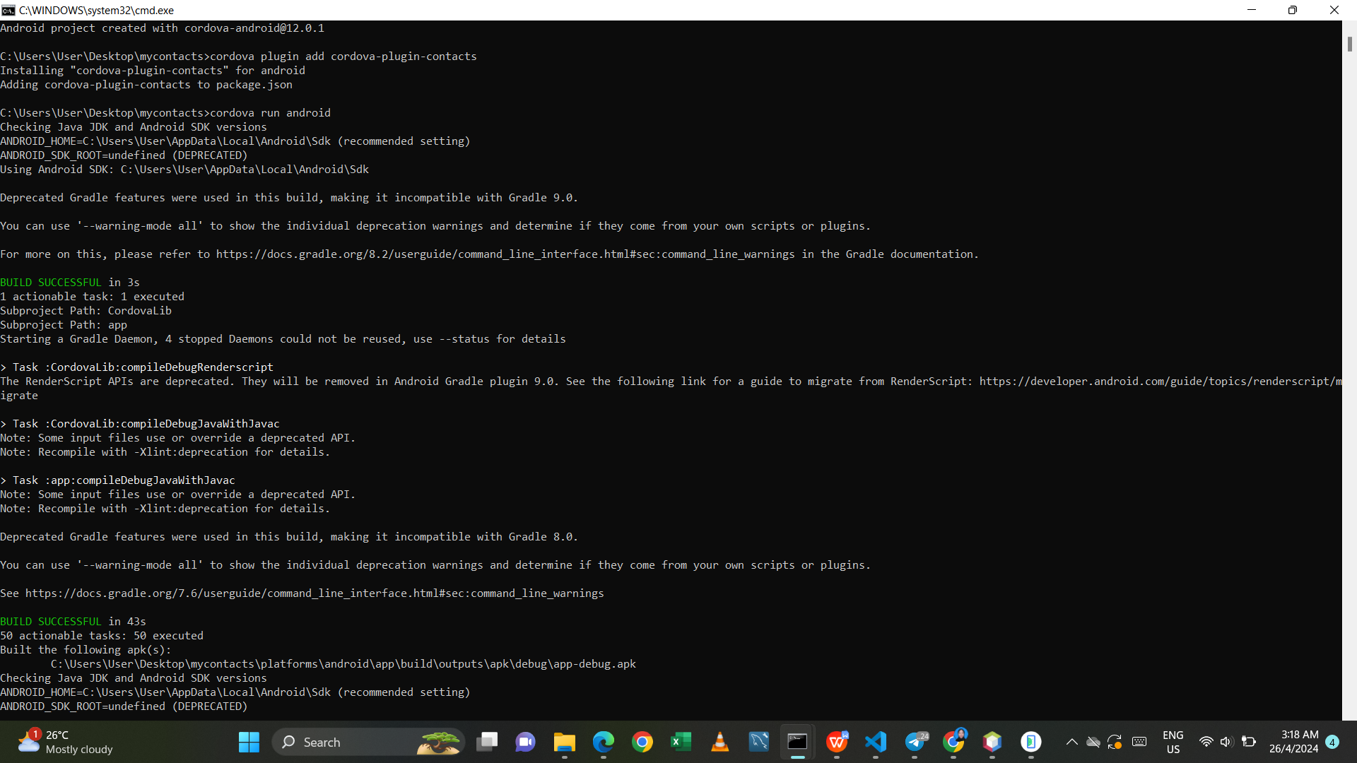

1. Output on android

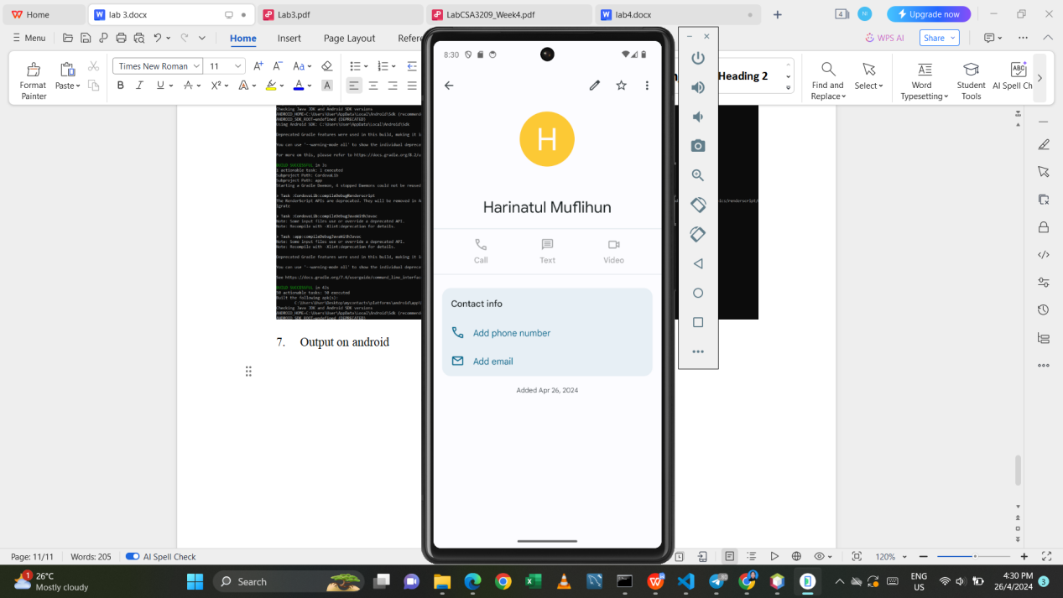 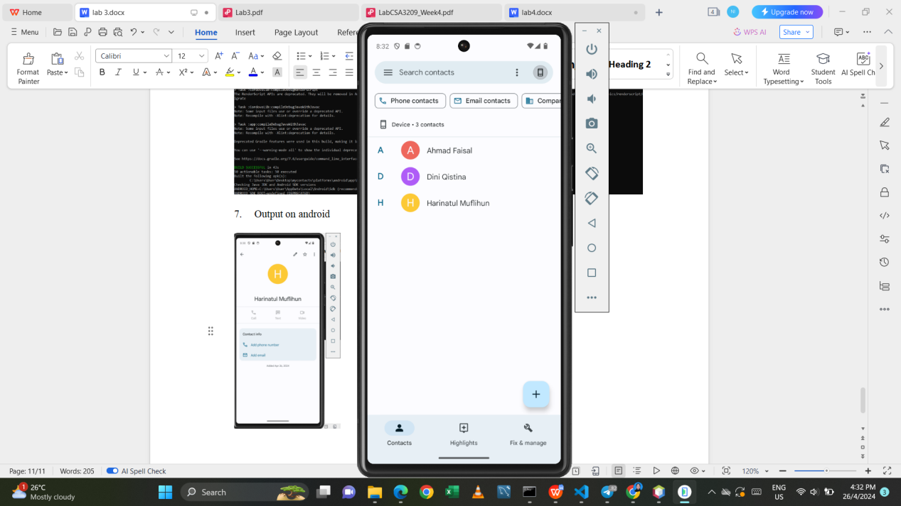

**Task 4 – Bootstrap in Cordova Project**

Create the same project as in Task 3, instead of hardcoding the name and telephone number, create a bootstrap form to get the contacts name and phone number and save into contact using cordovaplugin-contacts.

- create project

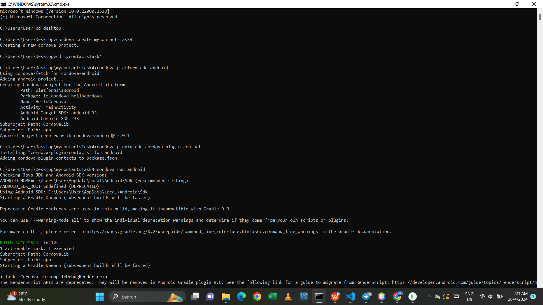

- index.html

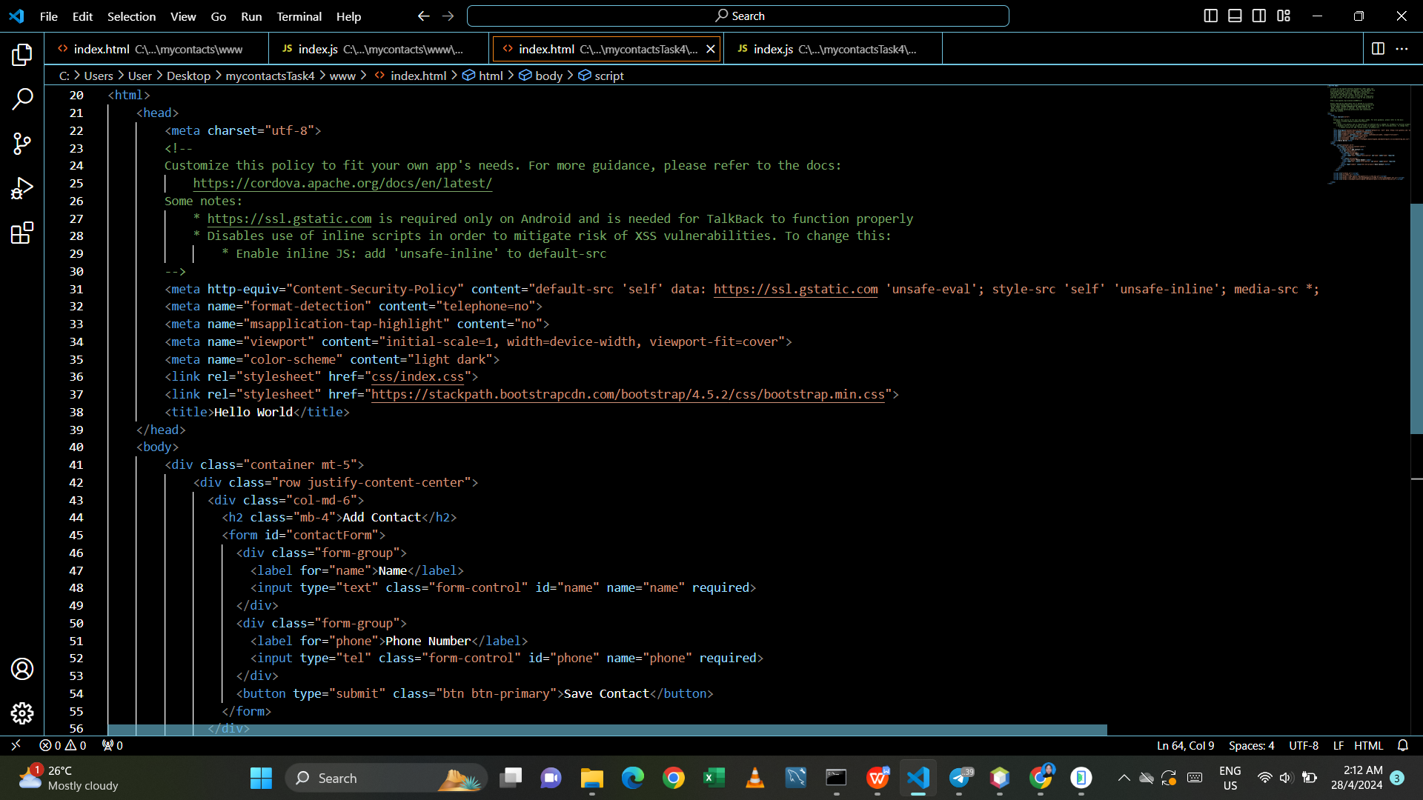

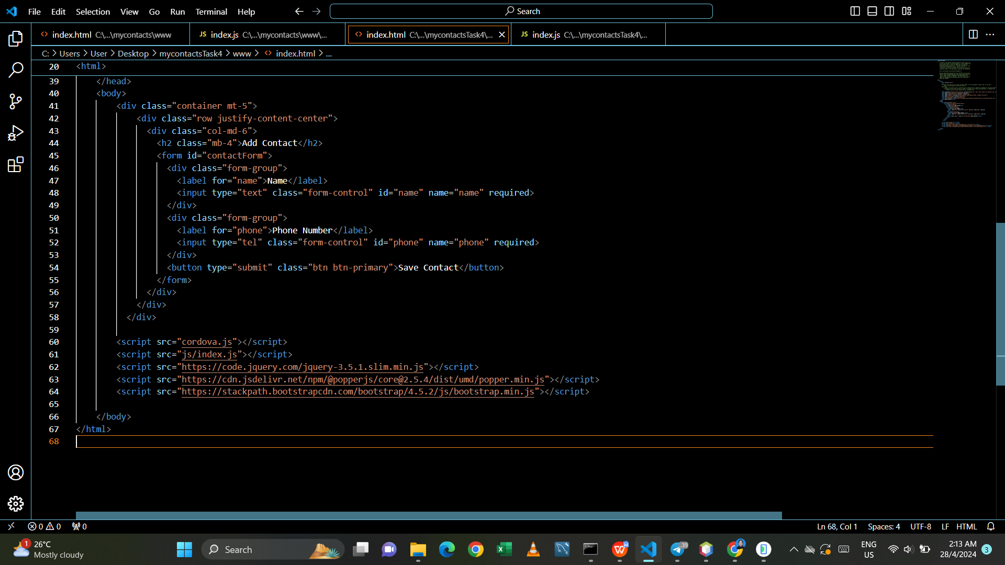

- Index.js

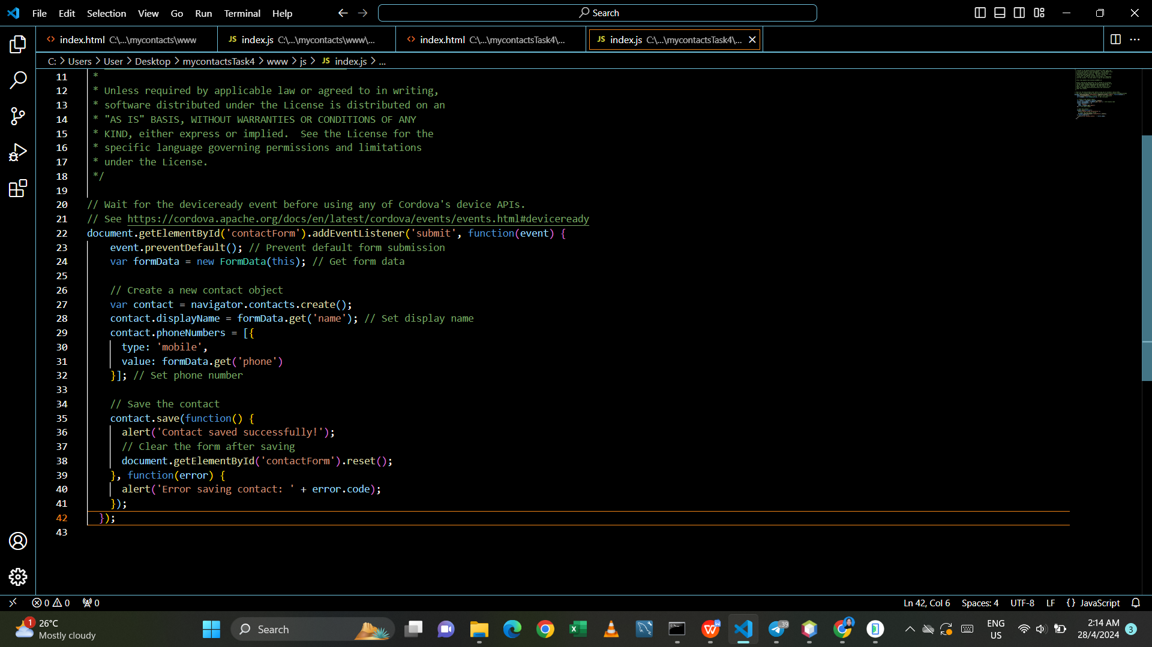

- run android

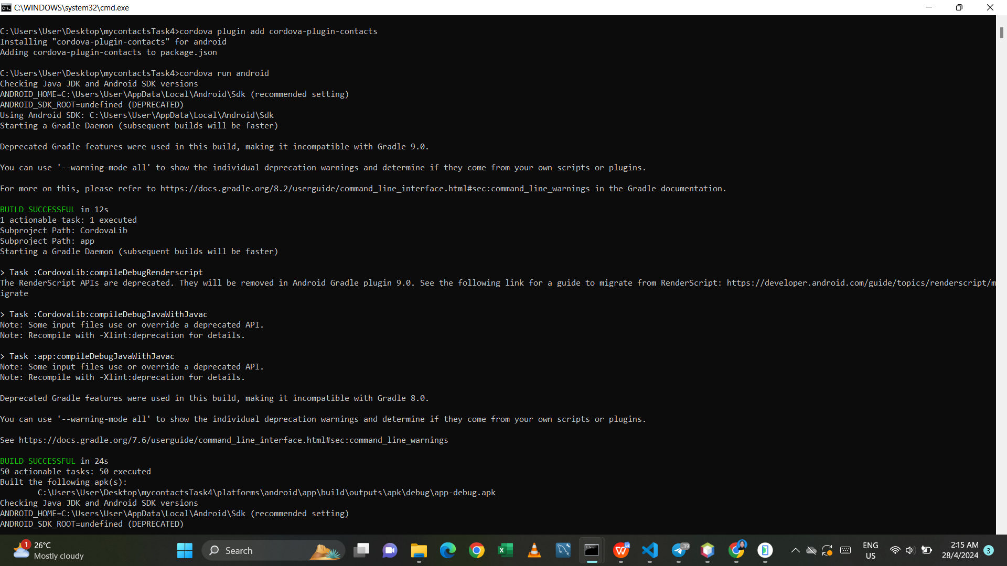

- output on android

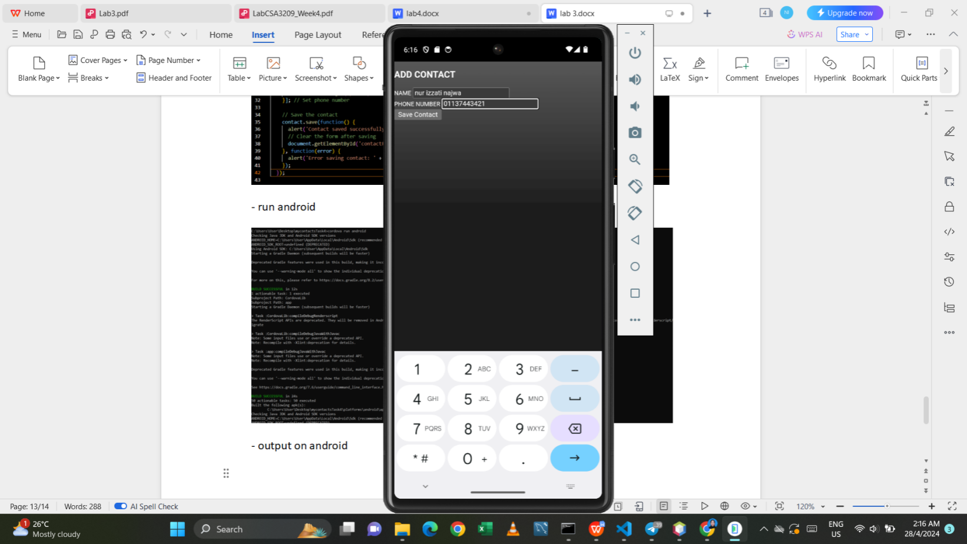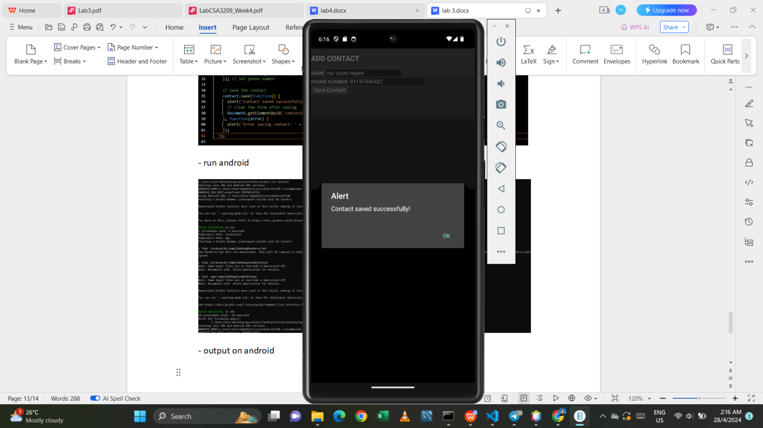

**Task 5 – cordova-plugin-device**

Explore the use and properties of cordova-plugin-device. Create a new cordova project to use this plugin and display all available information using the bootstrap.

- create project

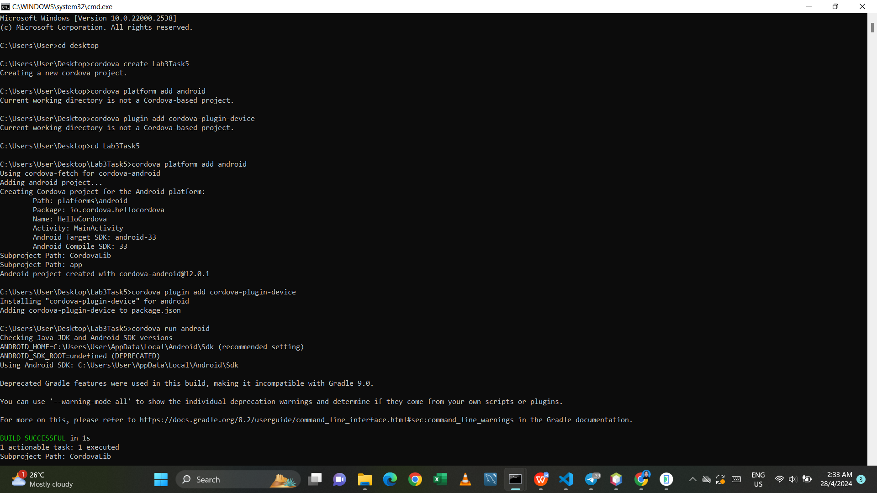

- index.html

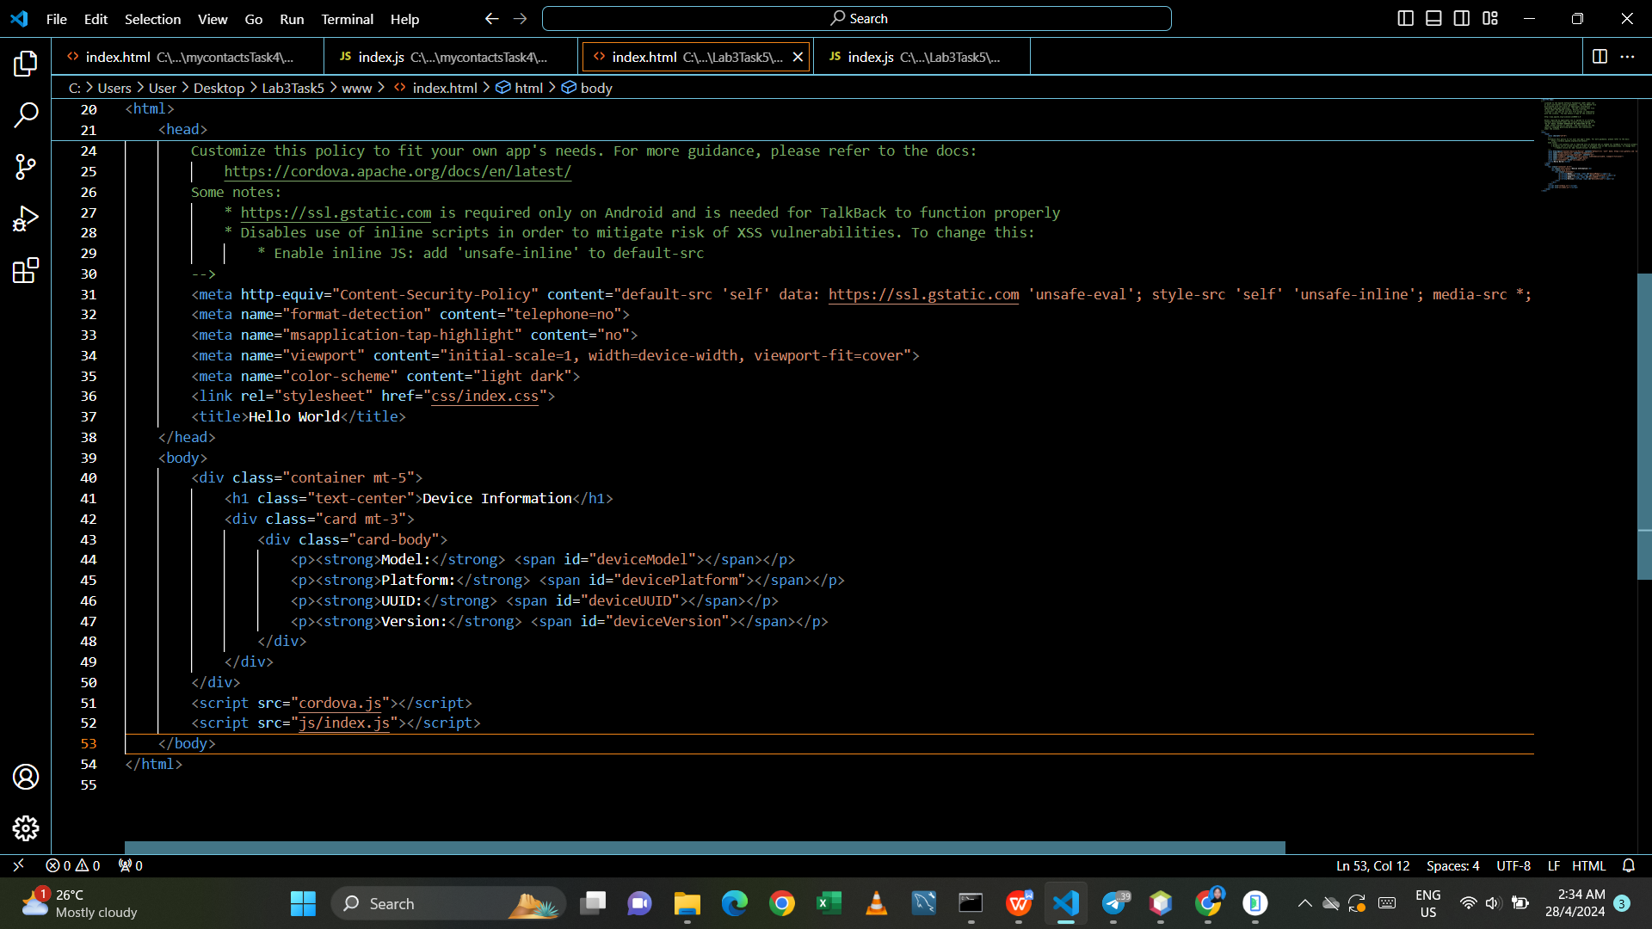

- index.js

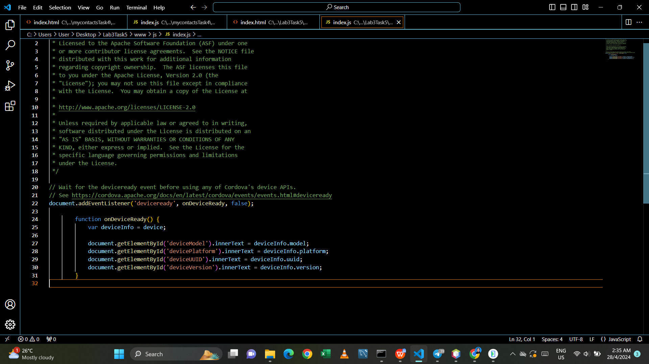

- run android

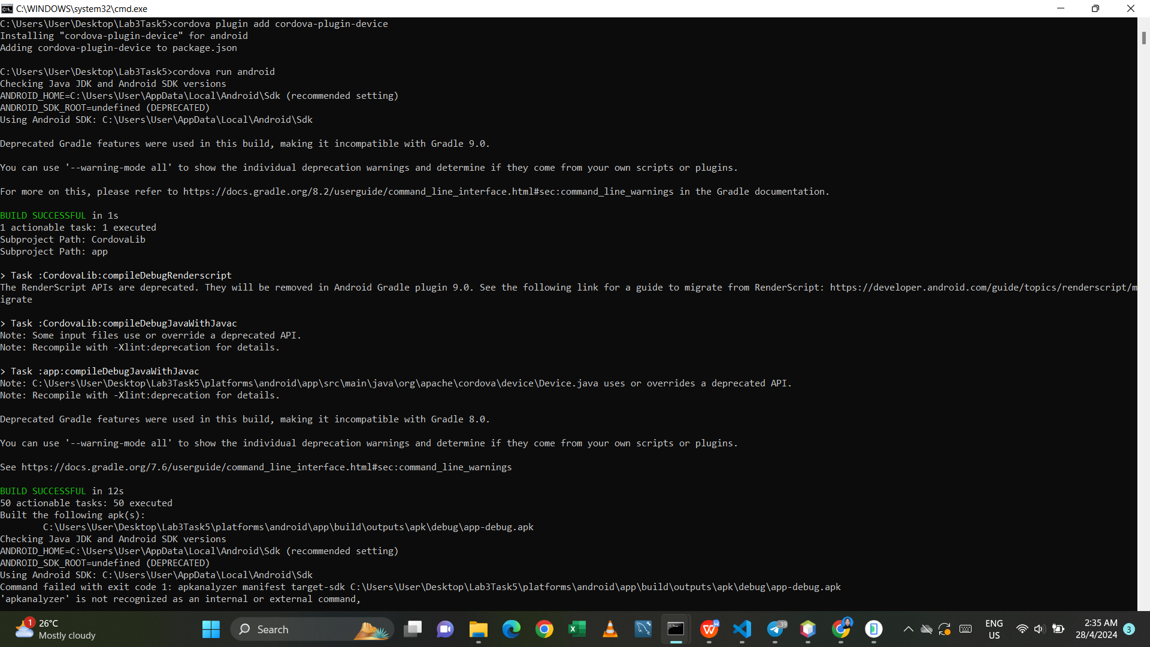

- output on android

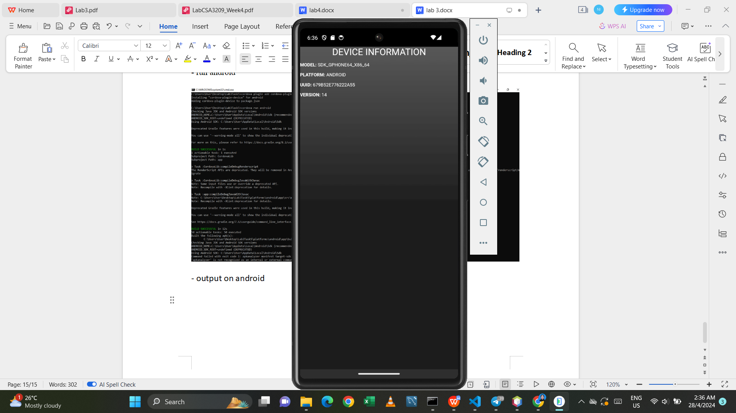

Github link: